**ARC-GIS**

**EXCERCISE: 1**



**BY – AMANUEL LEGESSE SOFTWARE ENG. EXT**

**ID – ATE/3628/11**

**GETTING TO KNOW**

**ARCGIS**

**1.A** : Start the program ArcCatalog and access spatial data

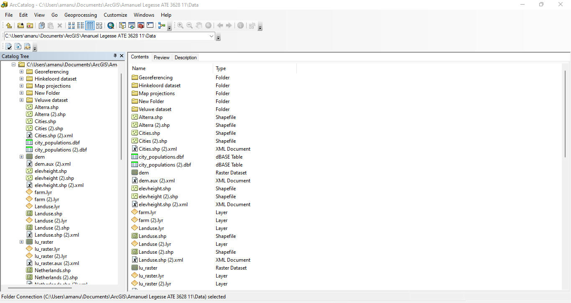

* The different file types of this folder are .shp, .xml, .dbf and .lyr

**1.B :**

* layer, database table and xml document

**Examining spatial data**

**2.A**:

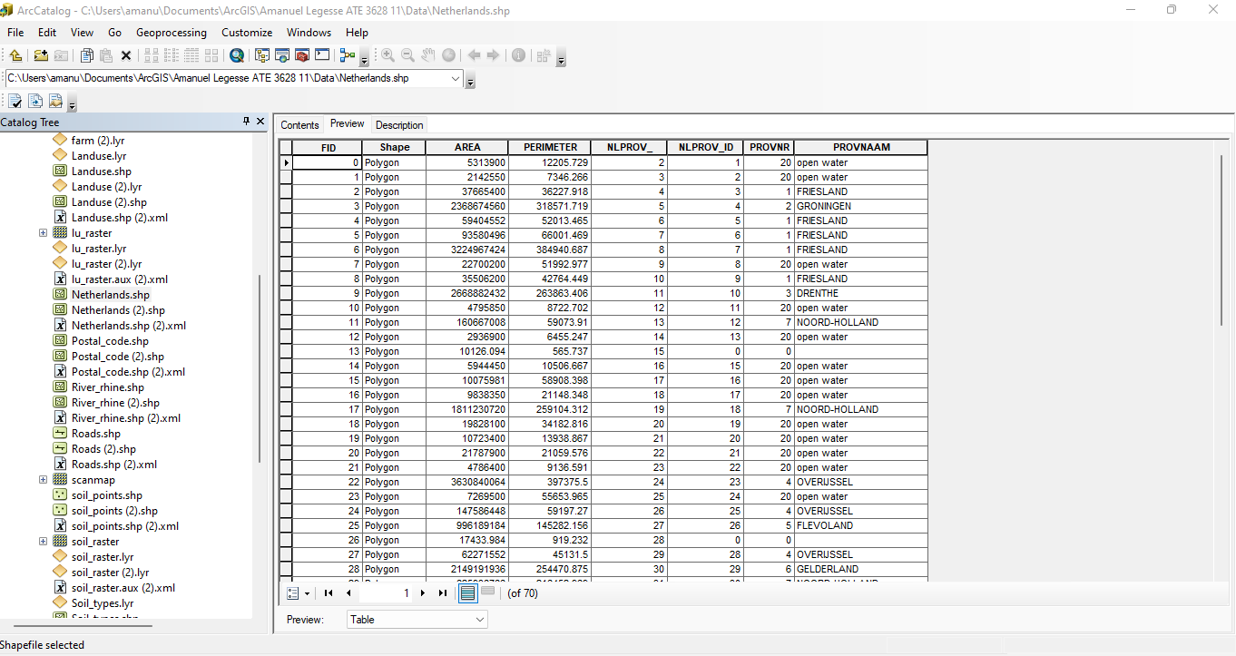

* The table contains 70 records and 8 fields.

**2.B:**

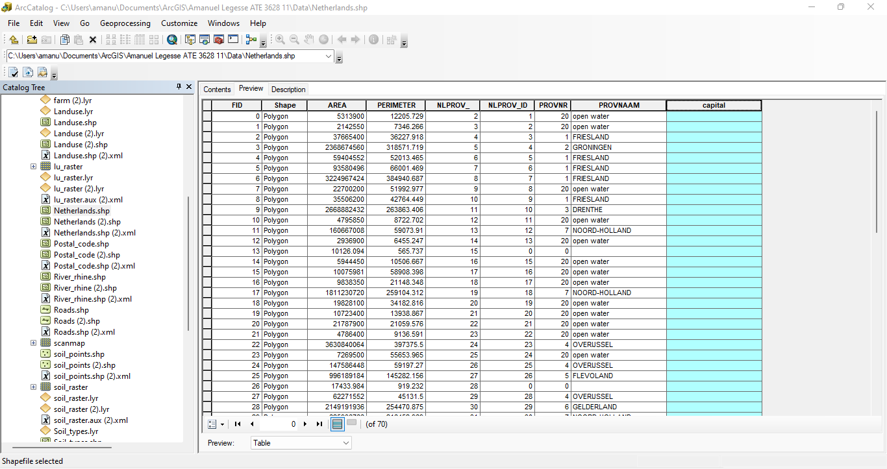

**2.D:**

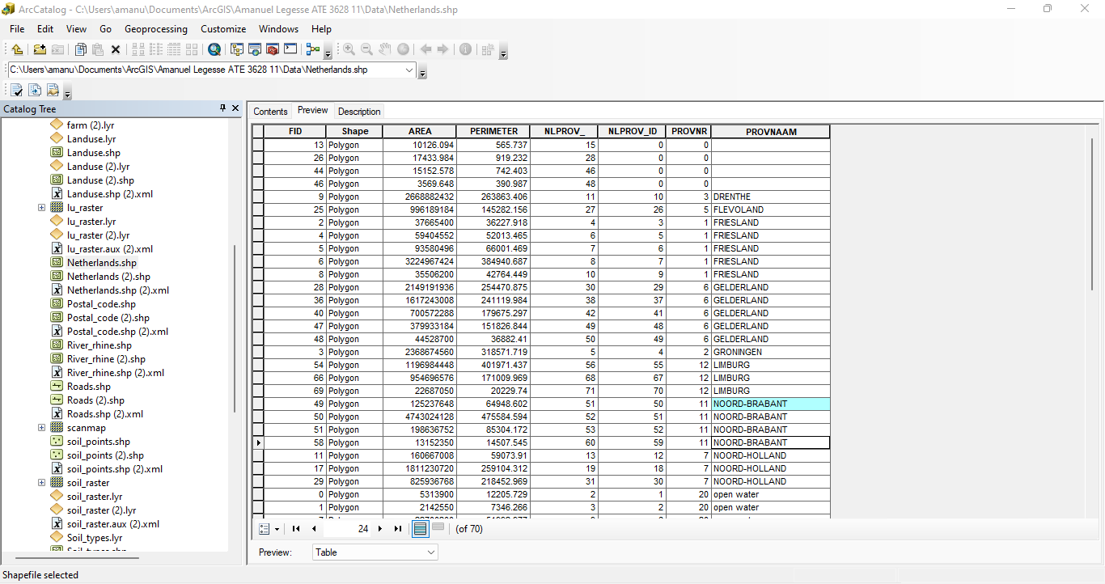

* 4 records belong to the province of Noord Brabant

**2.E :**

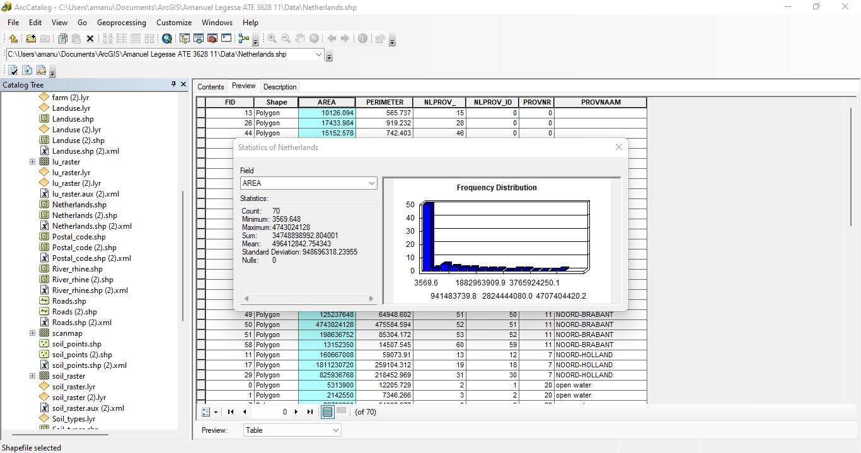

* The total area of Netherlands is 34748898992.804001

**2.F:**

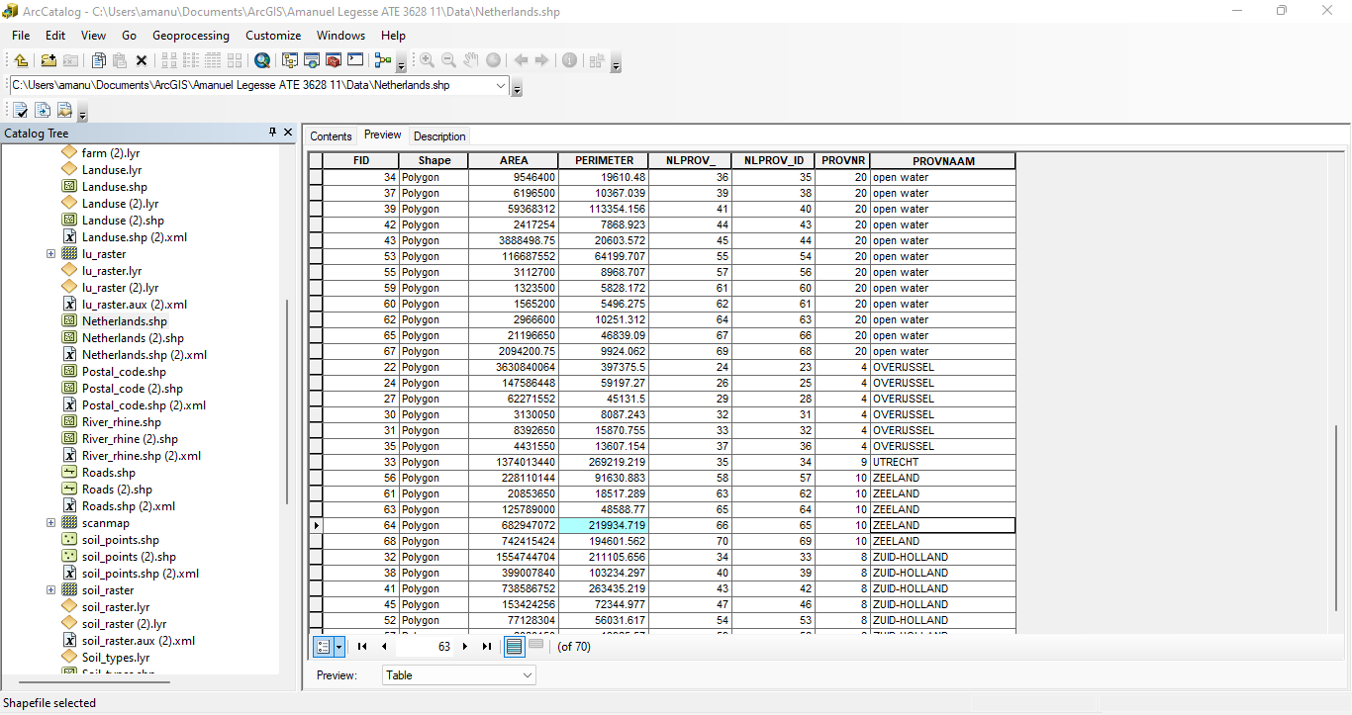

* ZEELAND province contains a feature that has a perimeter of 219934.719 meters.
* The value of the attribute ‘FID’ is 64.

**2.G :**

* ‘FID’ represents a value that uniquely identifies a record or feature.

**Exploring the metadata of a spatial dataset**

**3.A:**

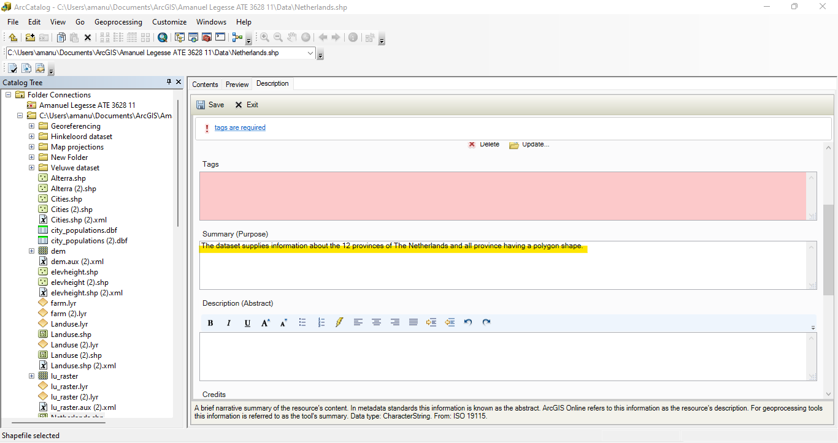

**3.B:**

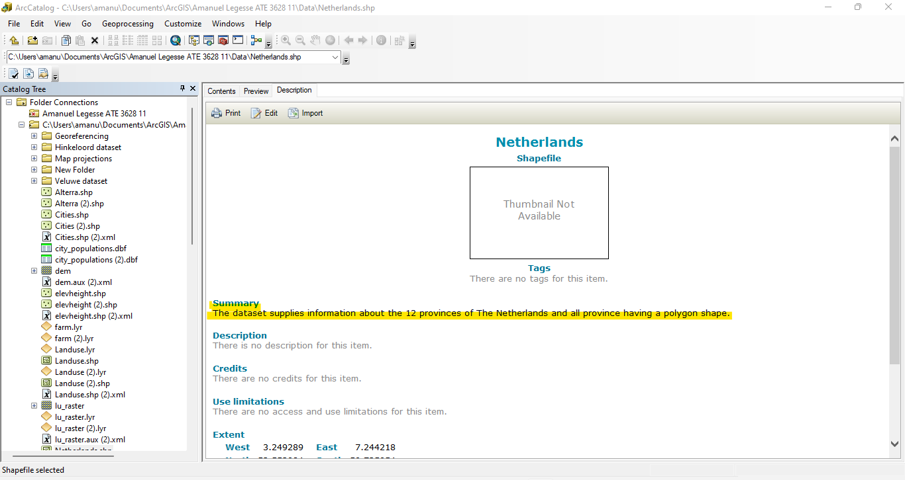

**3.C:**

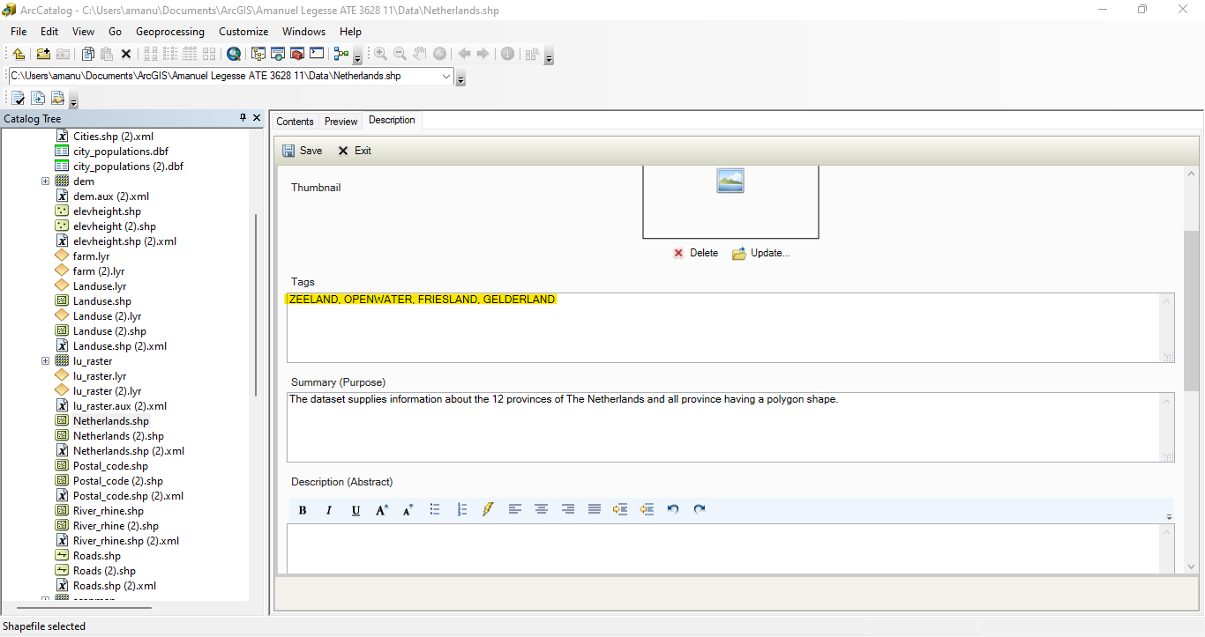

**3.D:**

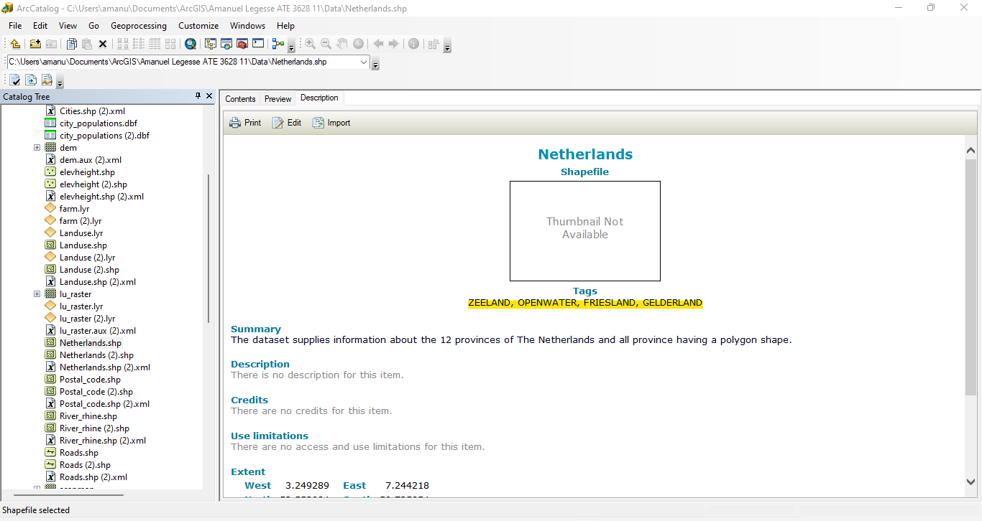

**Working with ArcMap**

**4.A :**

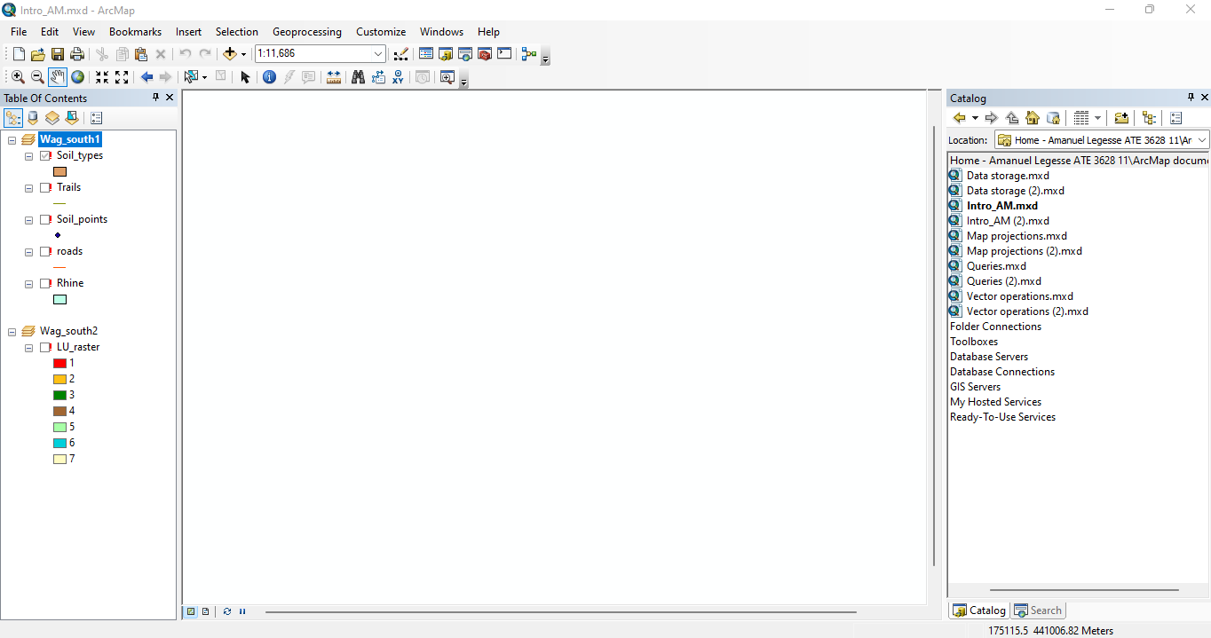

**5.A:**

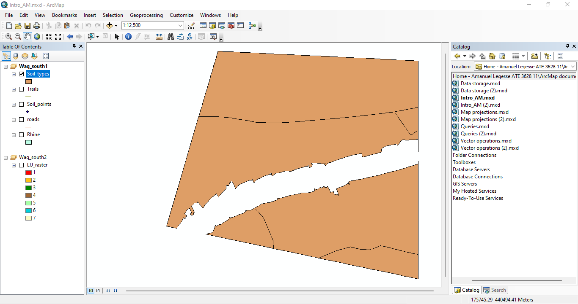

**6.A :** Activate a Data Frame and turn the visibility of a dataset on and off

* Intro_AM.mxd document contains 2 (Wag_south1 and Wag_south2) DataFrames.

**6.B :**

* Wag_south1 contains 5 datasets.

**6.C:**

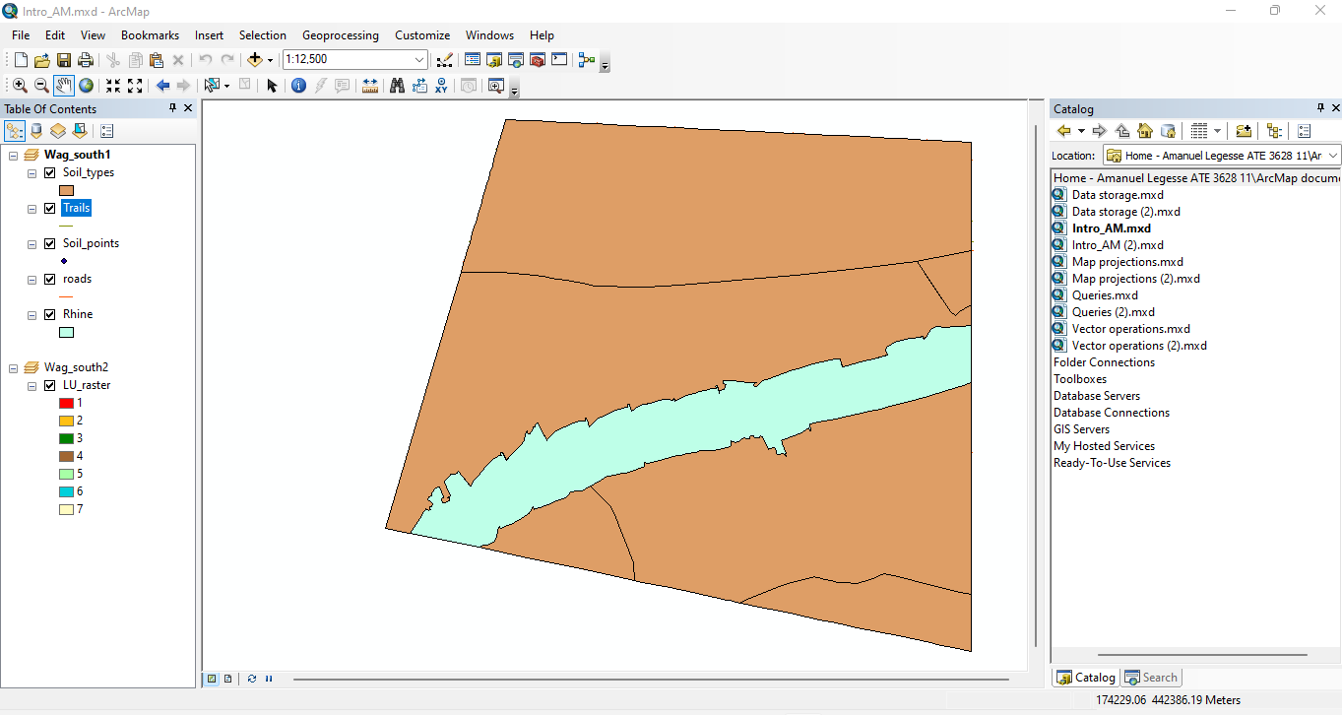

**6.D :**

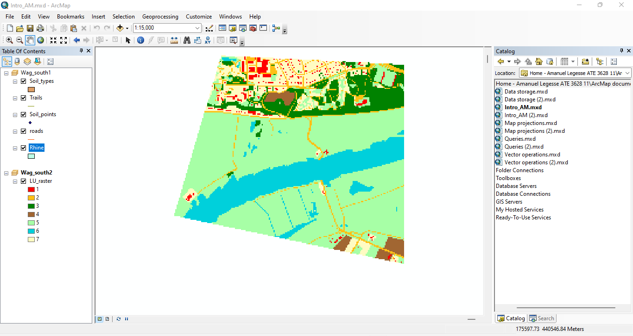

**6.E :**

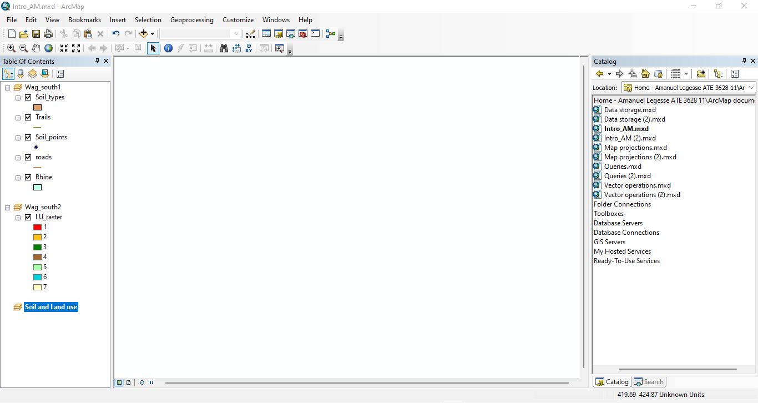

* **Adding datasets**

**7.A :**

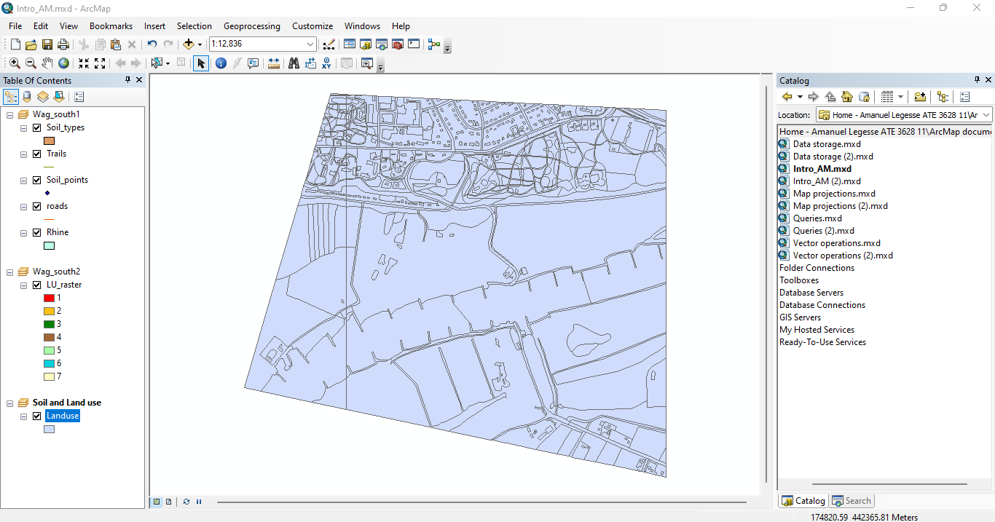

**Working with layer files**

**8.A :**

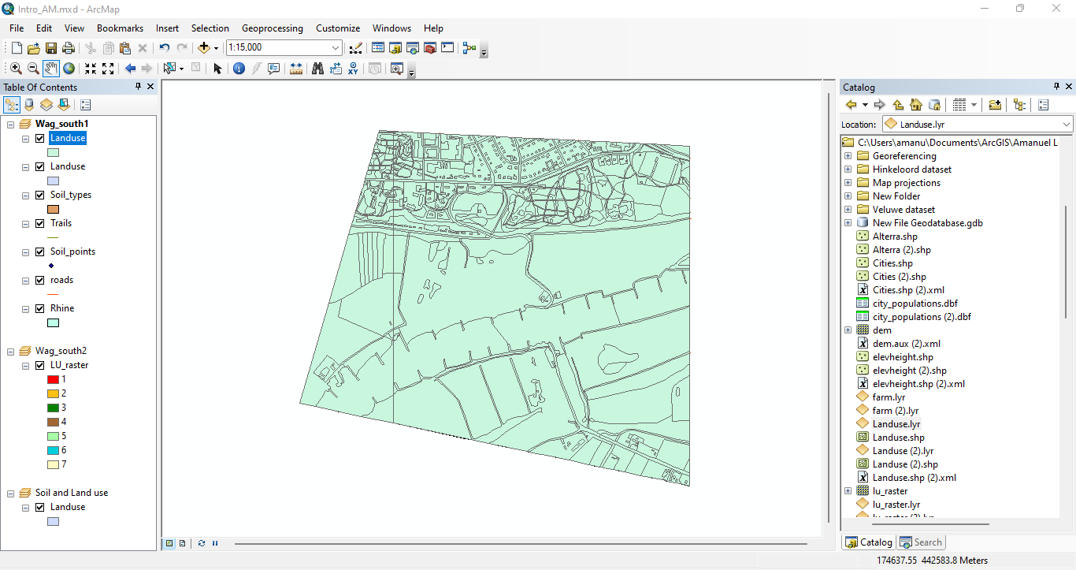

**8.B :**

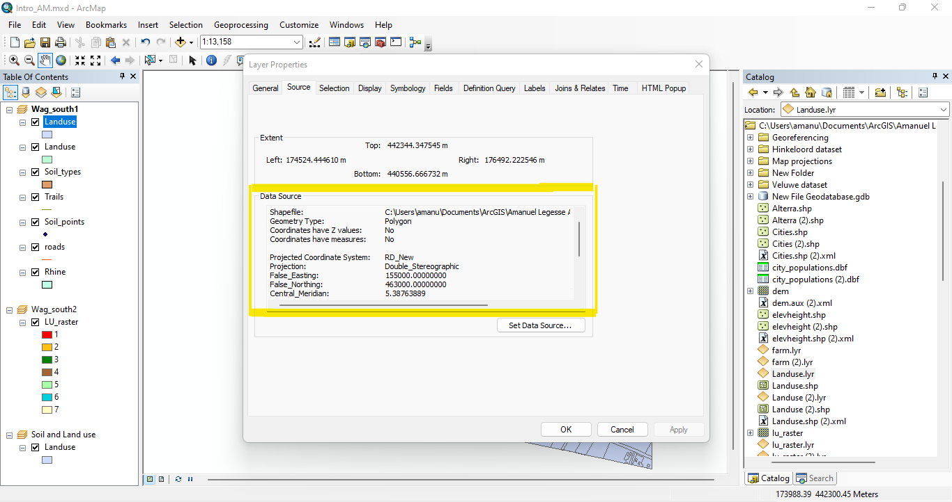

**8.C :** I tried changing the colorin the dataset ‘Landuse.shp’ nothing happens to the layer ‘Landuse.lyr’

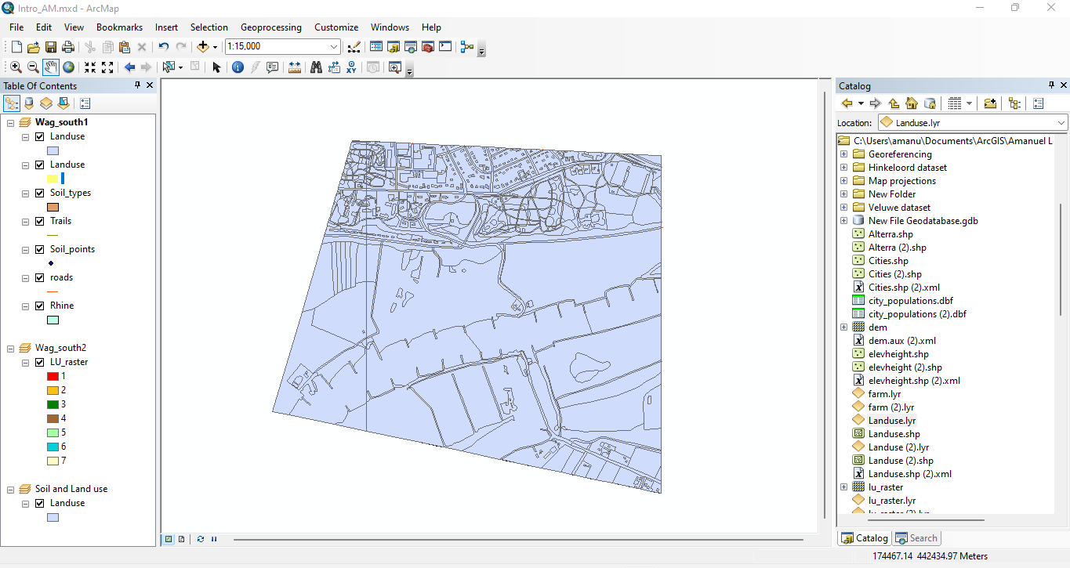

**9.A :**

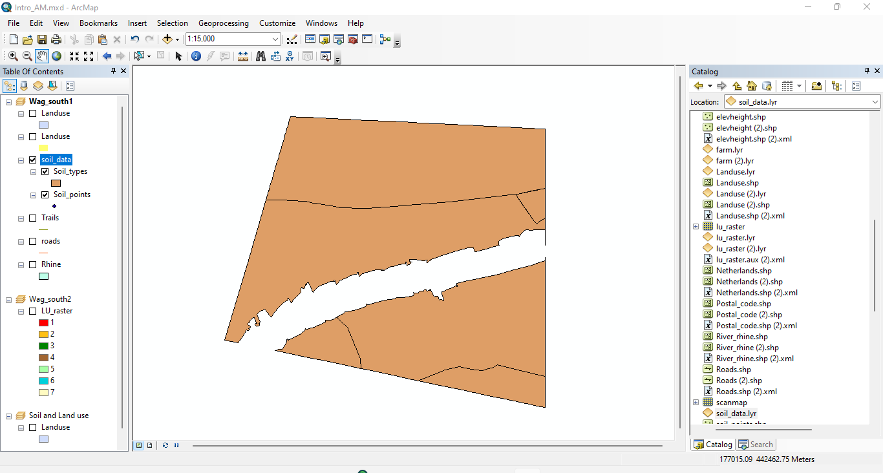

**9.B:**

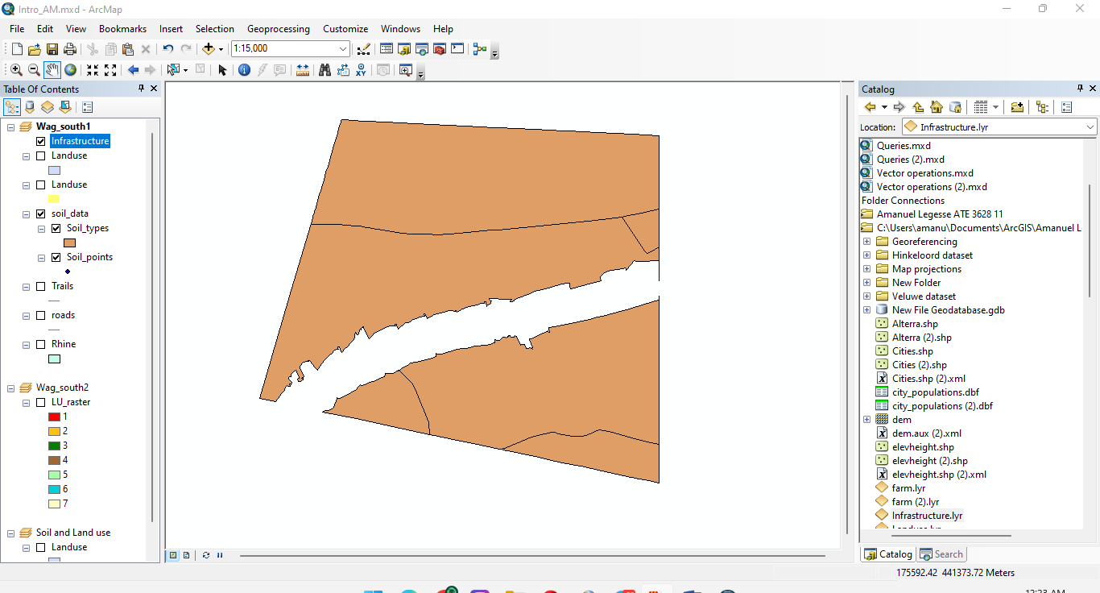

**9.C :**

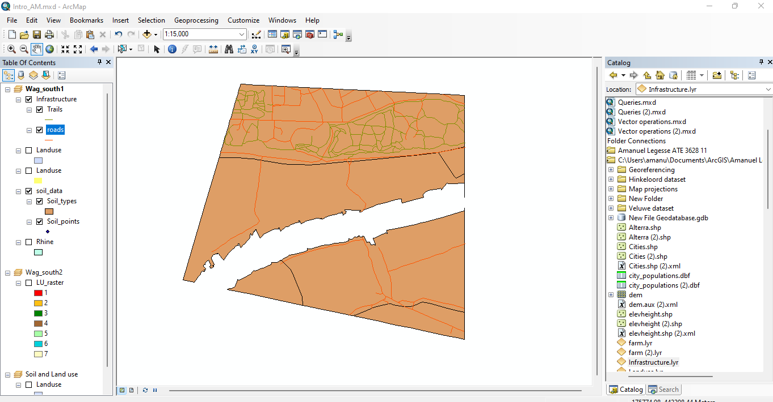

**9.D :** The other layers in the data set will disappear as if they have been deactivated but they are not, solid data will take over the infrastructure making the visibility on top hiding the other data sets

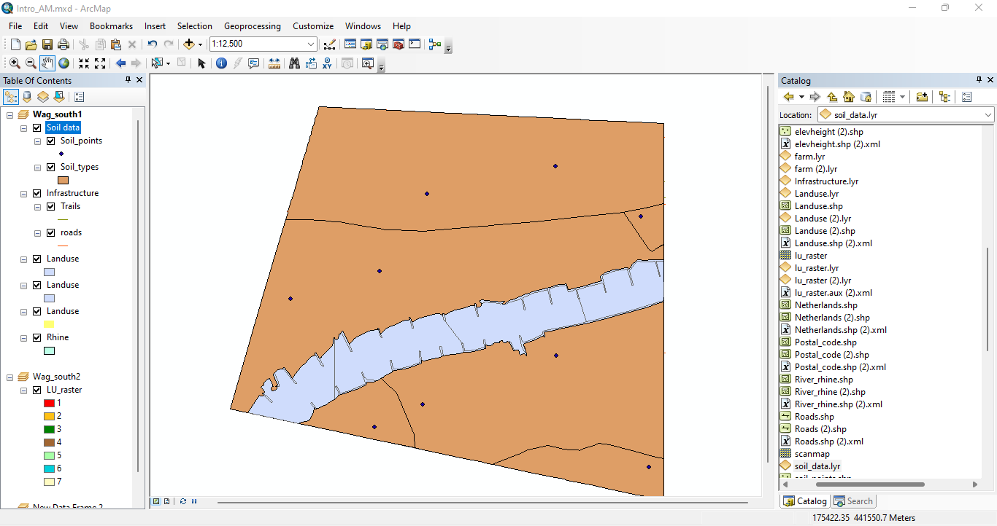

**9.E :** Roads and trails become visible because Solid data is deactivated since it was the primary data.

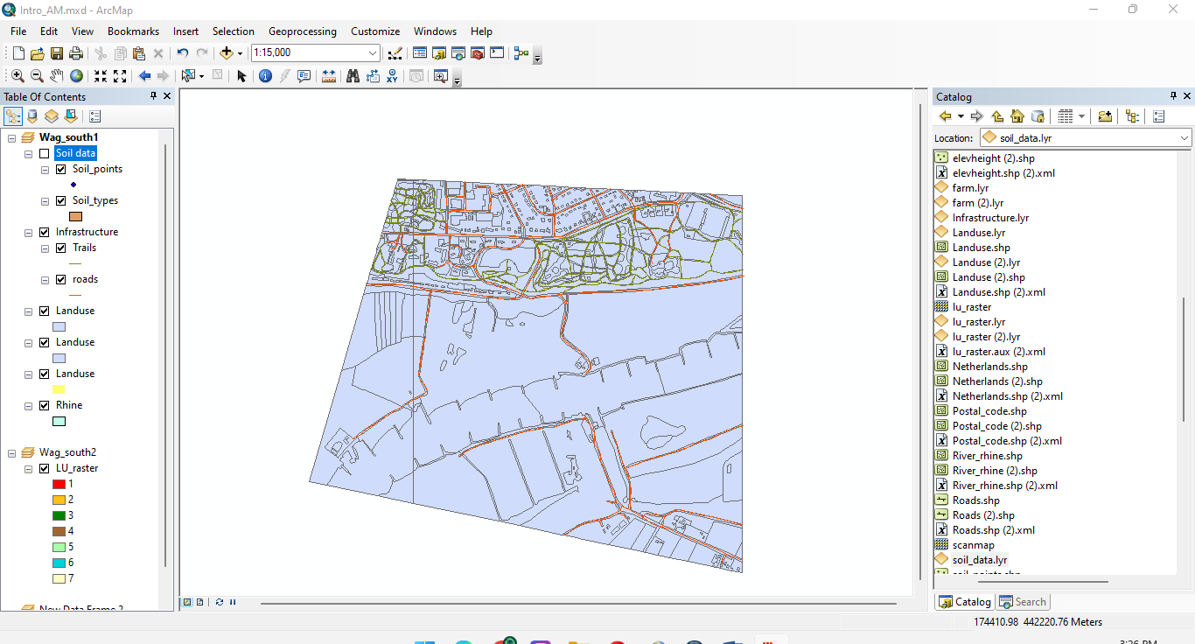

**9.F :**

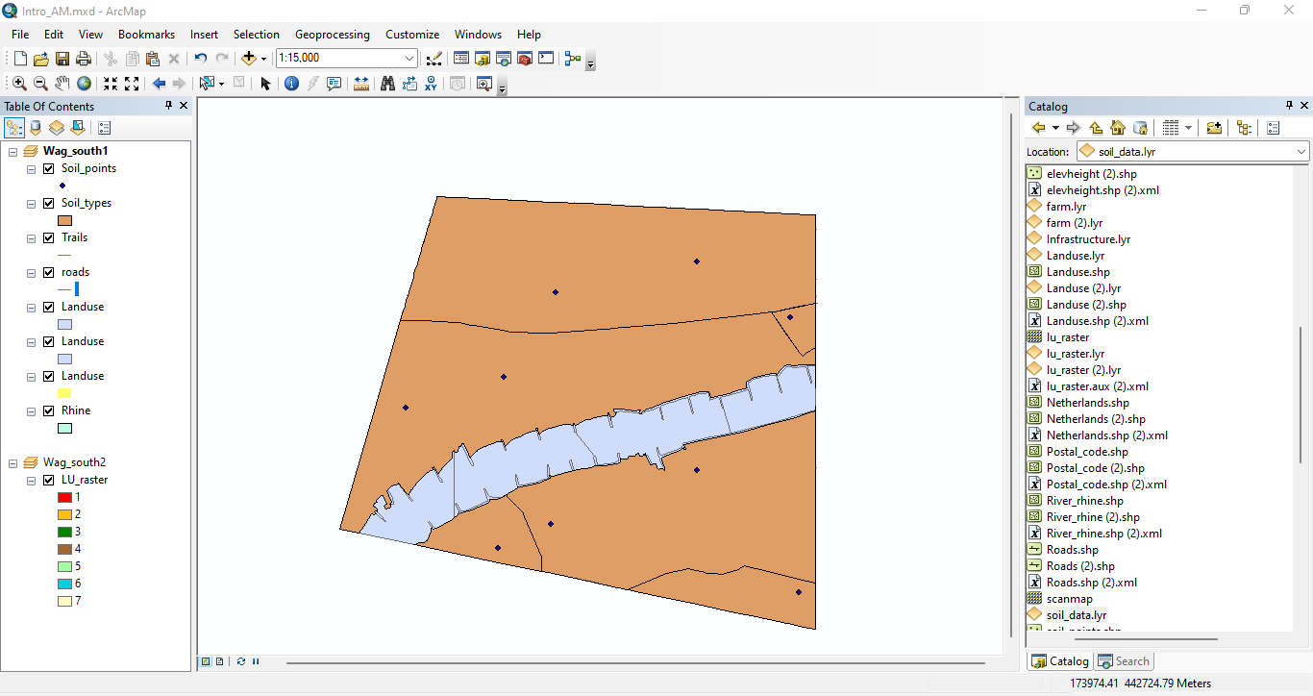

**9.G :**

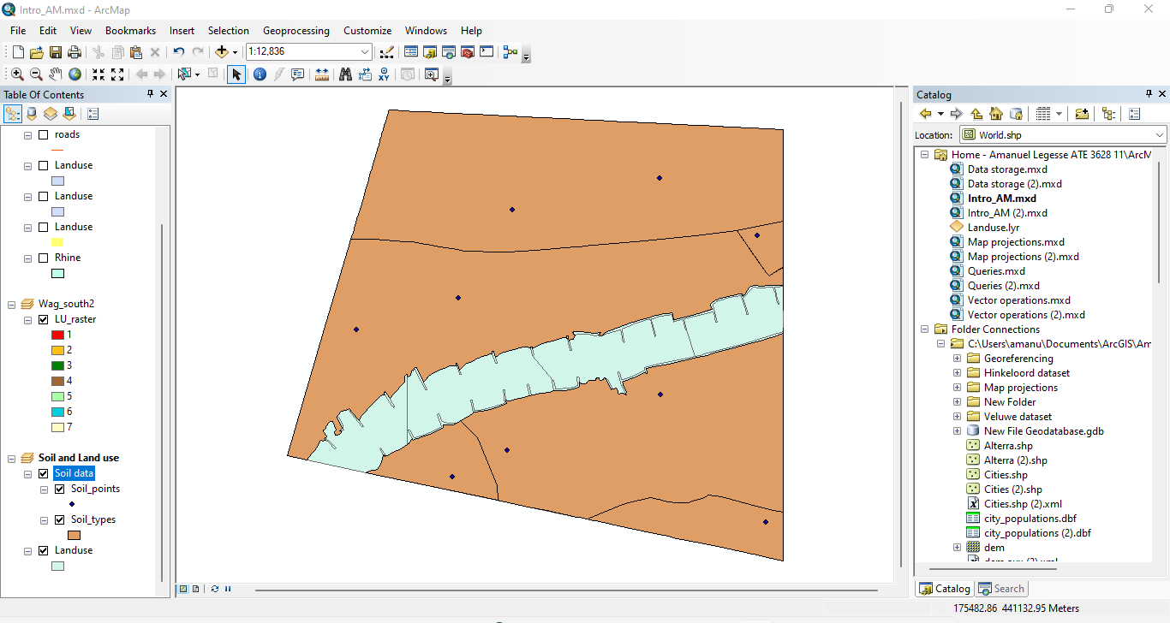

**9.G :** Removed the Data Frame ‘Soils and Land use’ from the ArcMap document.

**Zooming in and out**

**10.A :**

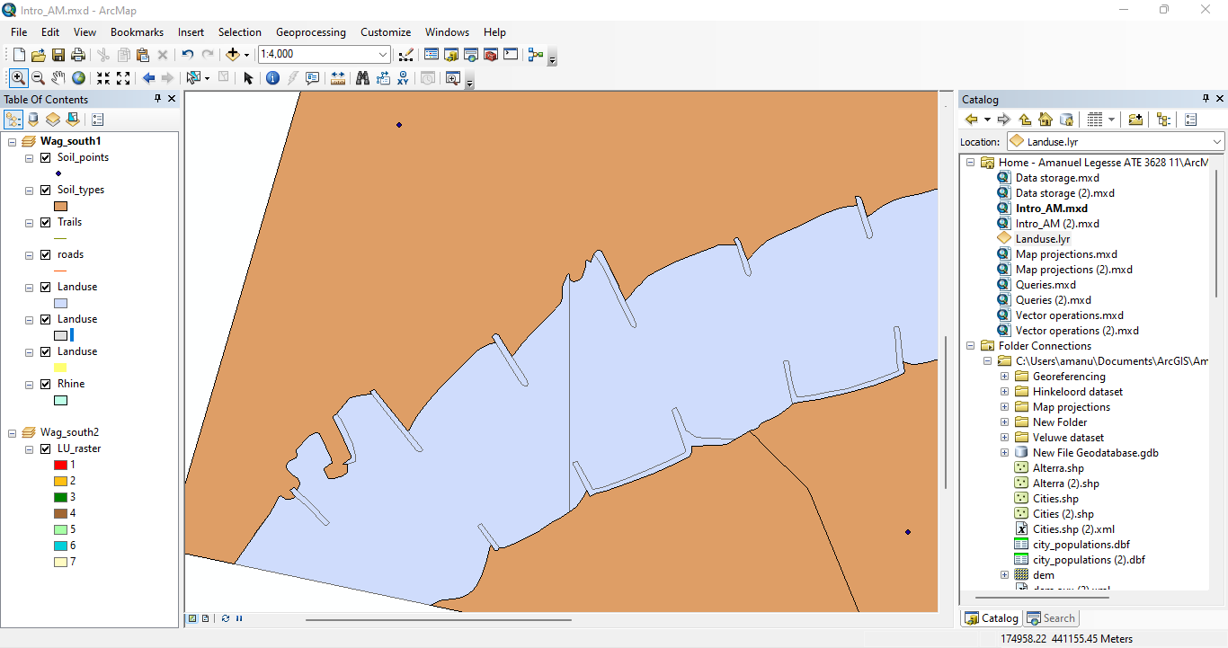

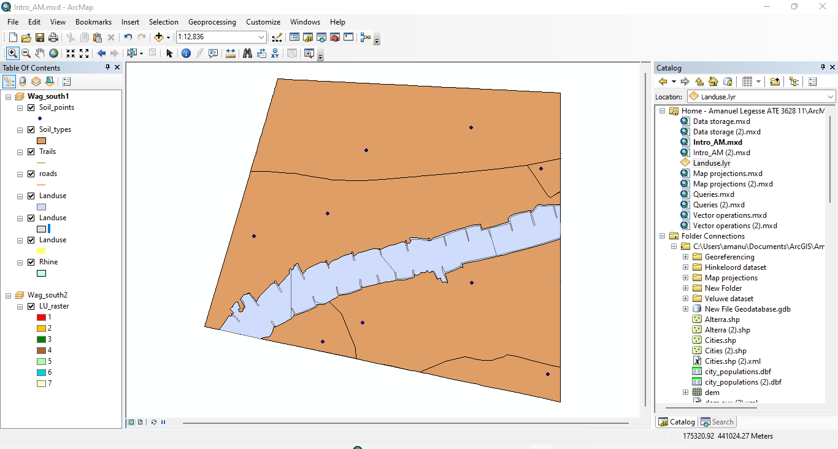

**Viewing a dataset’s attribute table**

**11.A :**

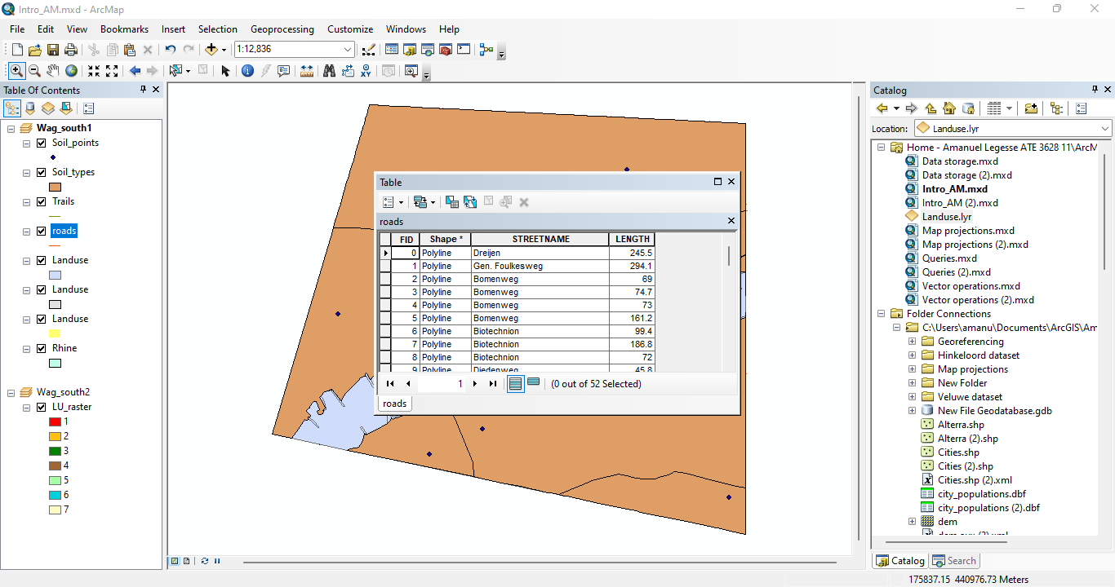

**A.1**

* The table contains a polyline feature type.

**A.2**

* There are 4 attributes. FID, shape, street name and length.

**A.3**

* The table contains 52 records.

**11.A.1 :**

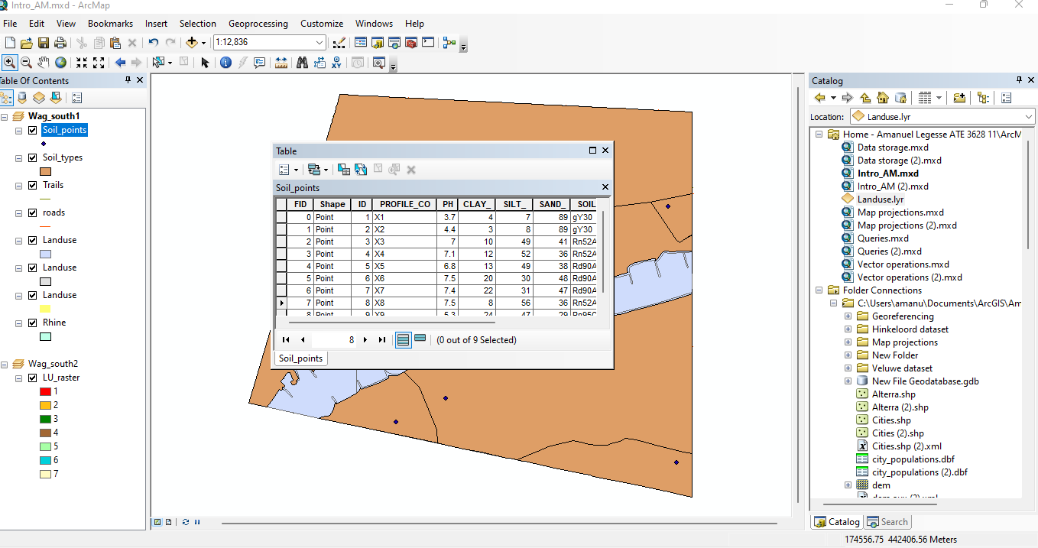

**B.1**

* The table contains a points feature type.

**B.2**

* There are 10 attributes. FID, ID, shape, profile_co, PPH, clay, silt, sand, soilcode and sc_ratio.

**B.3**

* The table contains 9 records.

**11.B.1 :**

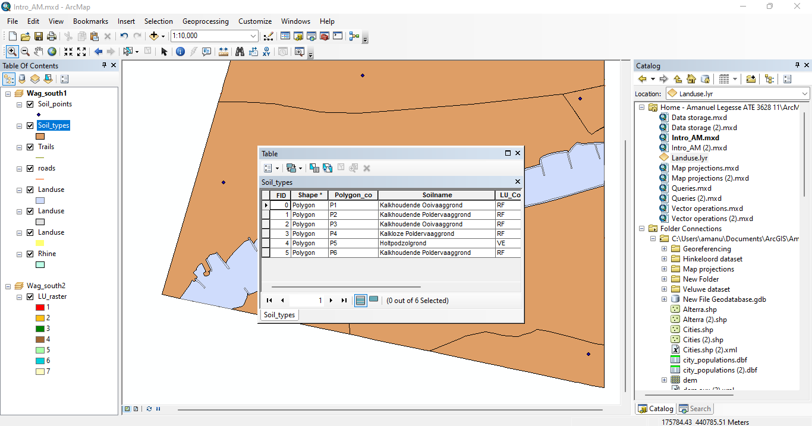

**B.1.1**

* The table contains a polygon feature type.

**B.2.1**

* There are 8 attributes. FID, ID, shape, polygon_co, soliname, solicode, lu_code, A.

**B.3.1**

* The table contains 6 records.

**11.C**

* Each column represents a field of the record. Rows and columns intersect to form cells, which contain a specific value for one field in a record.

**11.D :**

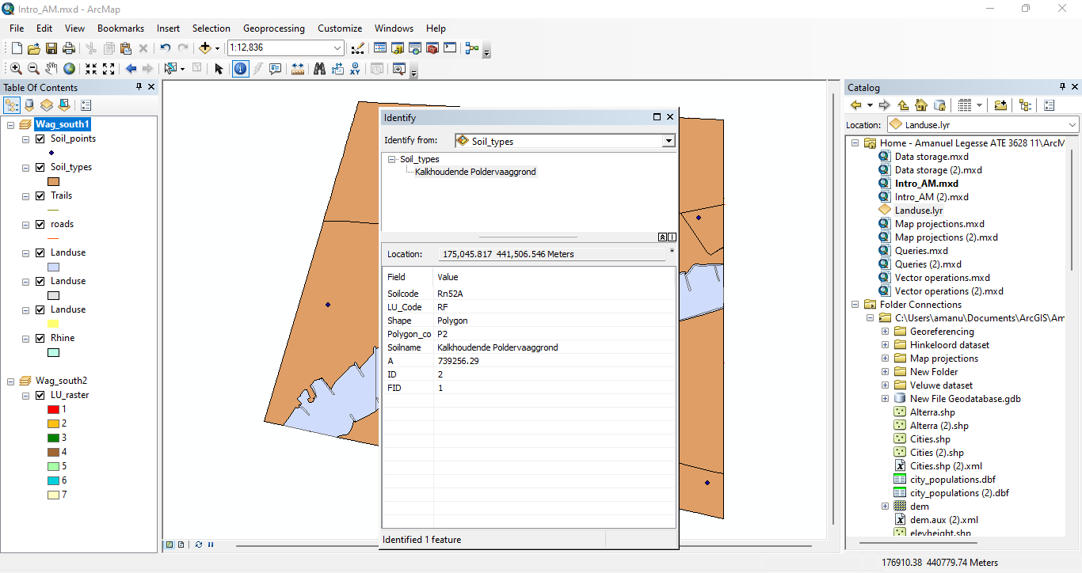

**12.A :**

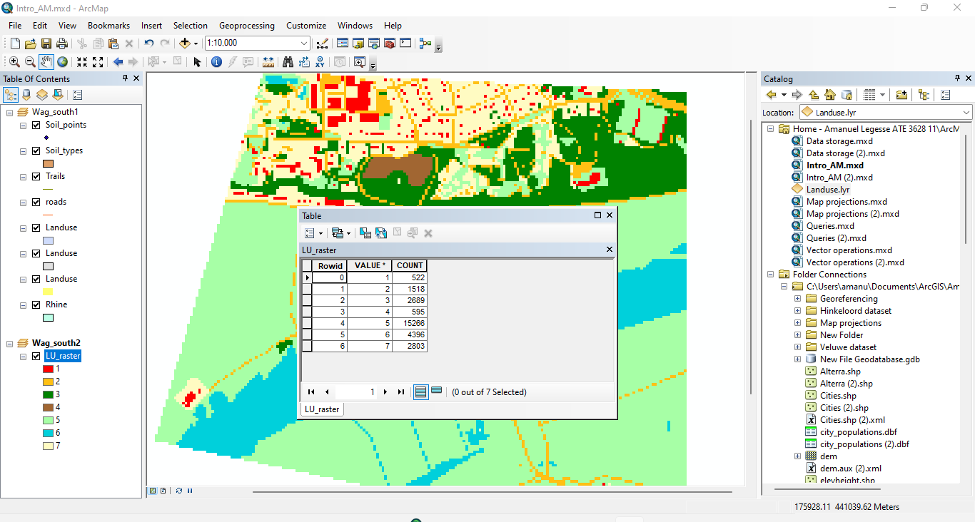

* There are 3 attributes. Rowid, Value and count.

**12.B:**

* The table contains 7 records.

**12.C:**

* **Count** command allows you to view the number of features in the map based on feature classes and subtypes.
* **Value** is a measurable quantity that may be passed to a function. Values are either assigned or determined by calculation.

**12.D :**

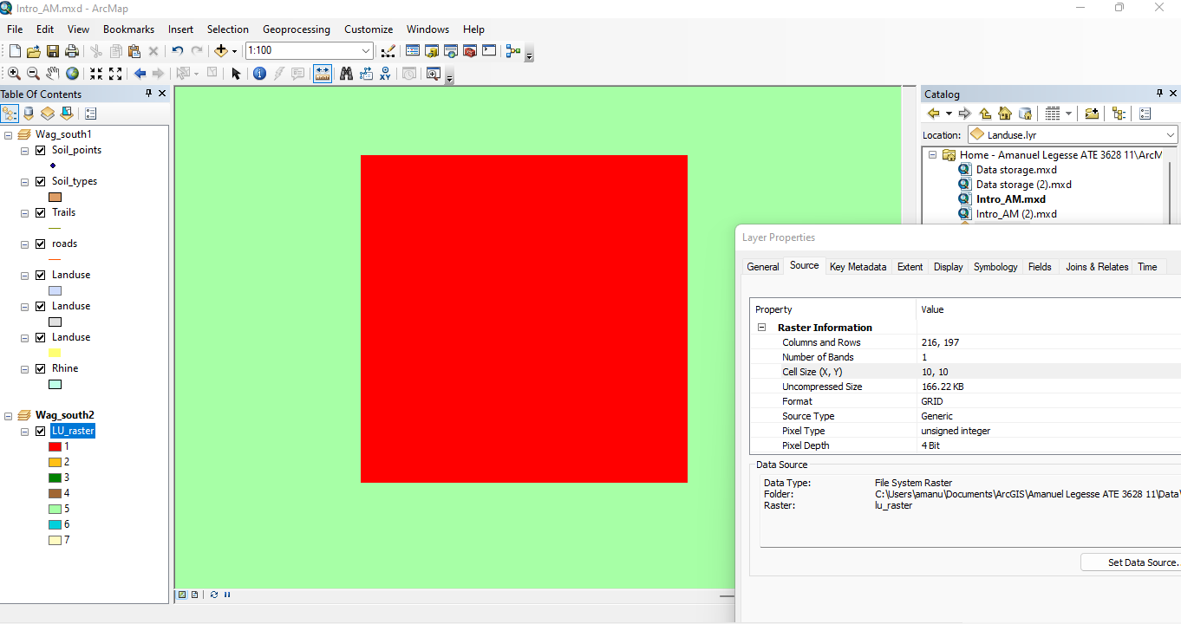

**Symbolizing spatial vector data**

**13.A :**

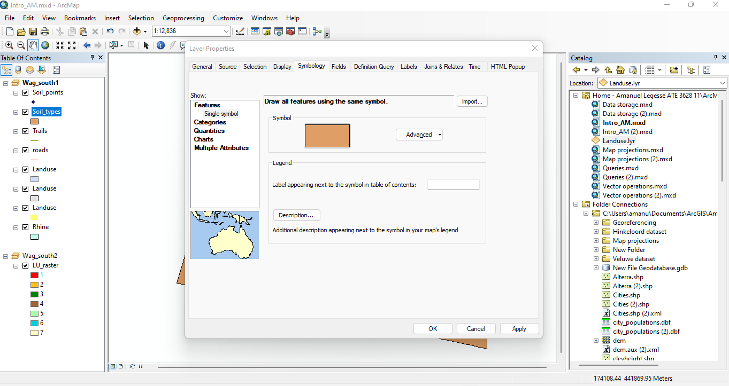

* The map type used is features.

**13.B :**

* I used the catagories – unique values map in order to choose the attribute to display on my map.

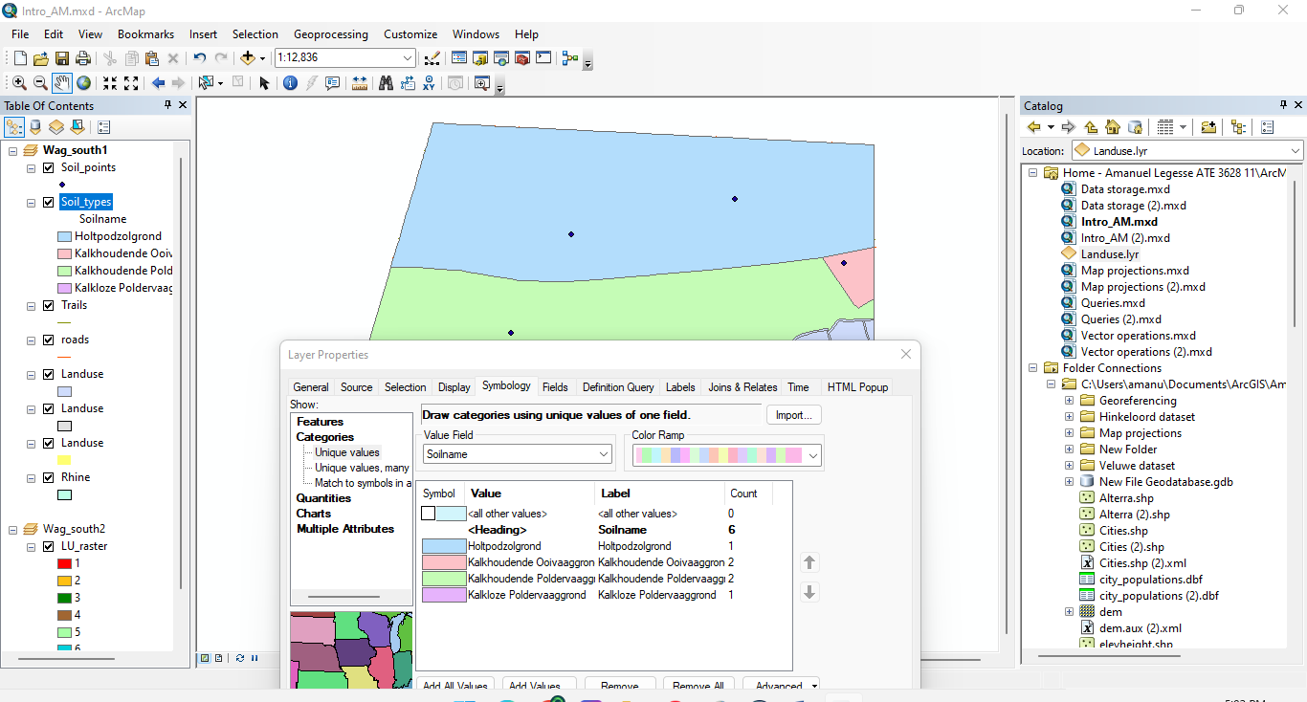

**13.C :**

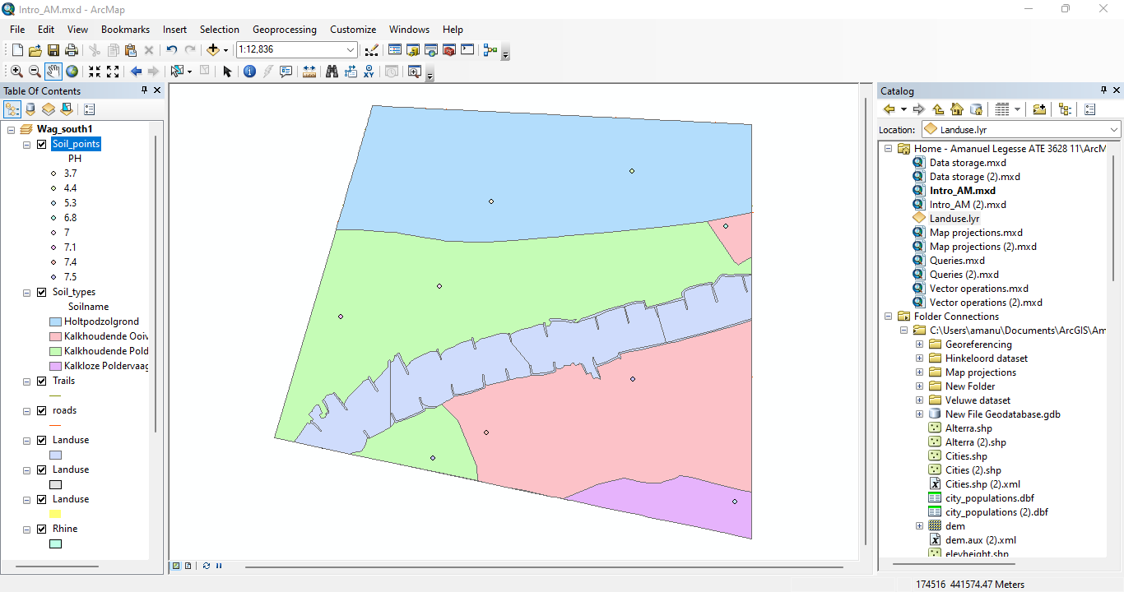

**13.D :**

* I used the catagories – unique values map in order to choose the attribute to display on my map.

**13.E :**

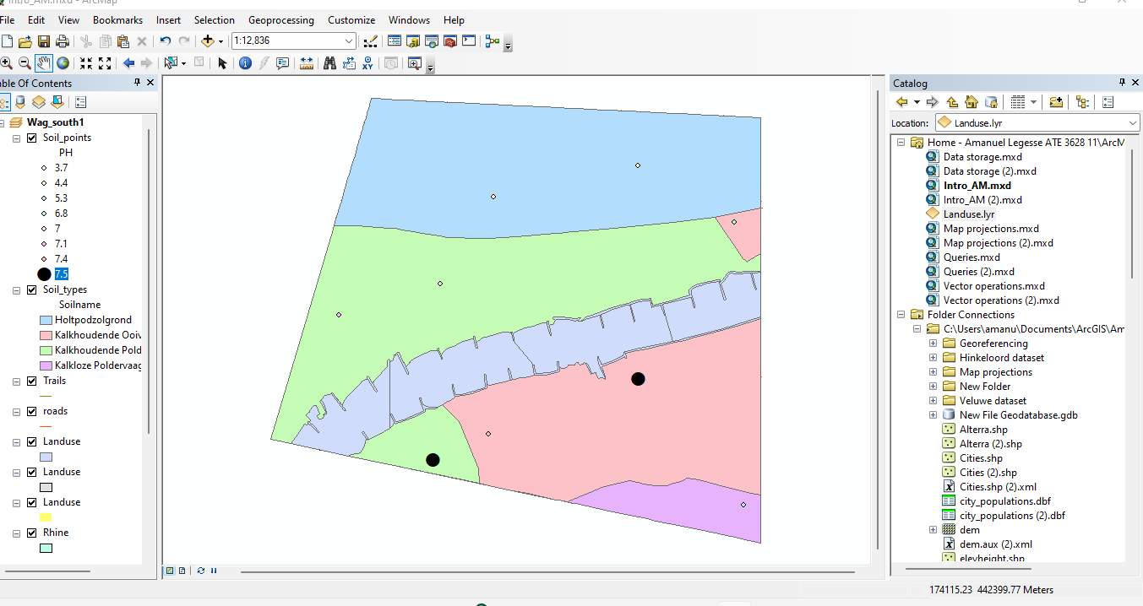

**14.A :** 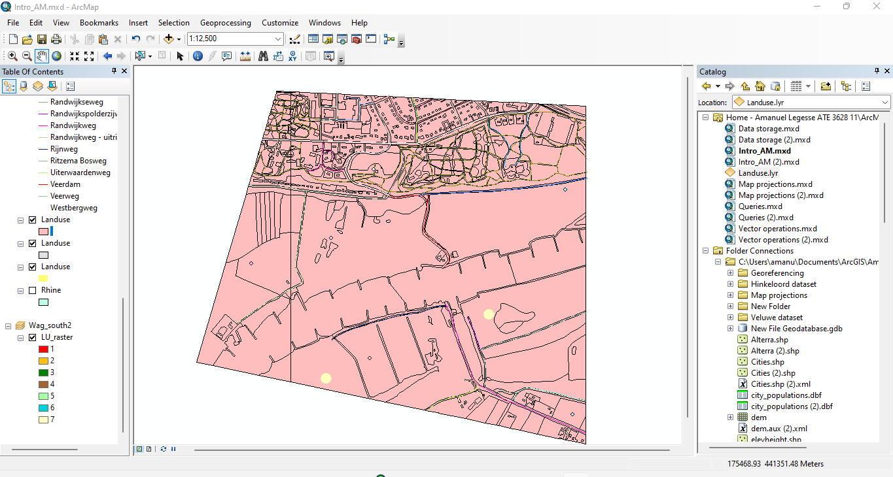

**14.B**

* The dataset contains 30 street names.

**14.C:**

* All the road features are polyline because features don’t depend on street names.

**15.A :**



**15.B:**

